**~CHAPTER-2 [Command-Line Editing]~**

**Command-Line editing:-**

The Problem with Traditional UNIX Shells:

* **Typing mistakes** are common with UNIX command-line usage due to **cryptic and terse syntax**.
* **Bourne and C shells** offer **very limited command-line editing**.
  + No built-in way to recall or fix previous commands.
  + BACKSPACE can only help before hitting RETURN — once executed, commands are gone.

**🔹 History Mechanism in the C Shell:**

* Slight improvement with **command history**.
* However, **editing past commands is awkward and limited**.  
  🔹 Bash Shell Improvements:
* Bash introduces **command-line editing** similar to full-screen text editors:
  + Supports **emacs-mode** and **vi-mode** for editing.
* Includes a **powerful history mechanism**:
  + fc (fix command): lets users edit previous commands using their **favorite editor**.
  + Still supports **C shell-like history features** for compatibility.

🔹 Control Key Conflicts:

* Both editing modes (vi and emacs) may conflict with **UNIX terminal control keys** (e.g., those set with stty).
* Users should be aware of potential **keybinding clashes**.
* The chapter provides **warnings and guidance** when such conflicts may arise.

**#Bash maintains a history list of commands typed during each interactive session.**  
1} On startup, bash **loads history from** the ~/.bash_history file.  
2} Each interactive shell session has **its own history list**.  
3} On exit, the session's command history is **saved back to .bash_history**.  
4} You can **change the history file name** by setting the HISTFILE environment variable.  
5} Additional command history variables (like HISTFILE) are discussed in the next chapter.

**#Emacs editing mode in bash is a simplified version of emacs.**

It operates on a single command-line (one-line window).

Supports basic emacs commands for:

* Cursor movement
* Cut-and-paste
* Search

Table 2-1. Basic emacs-mode commands

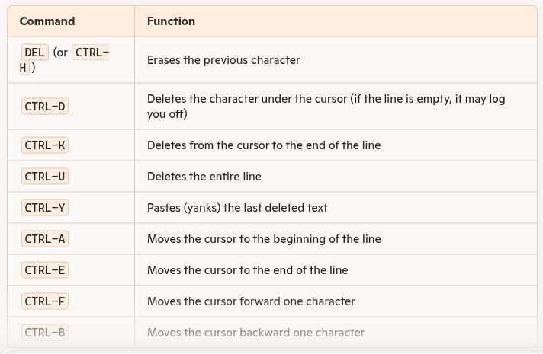

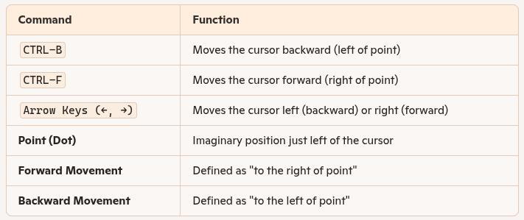

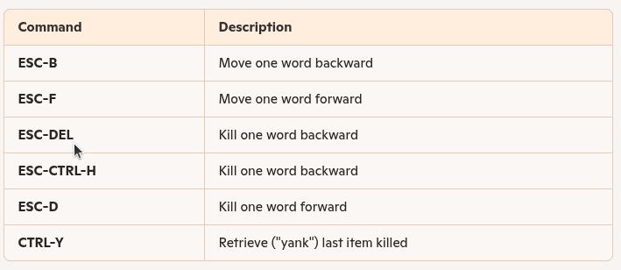

Table 2-3. emacs-mode line commands:-

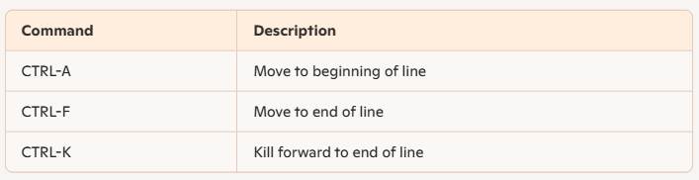

Table 2-4. emacs-mode commands for moving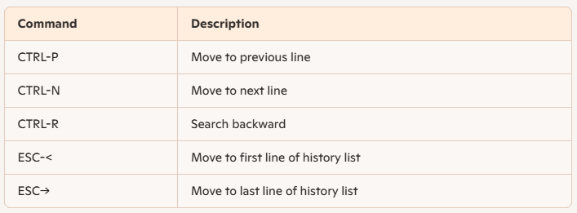

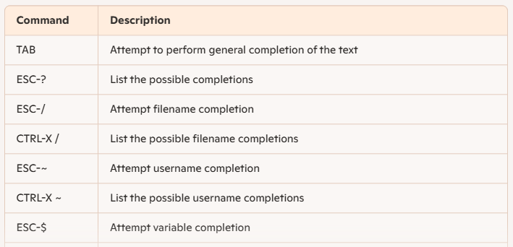

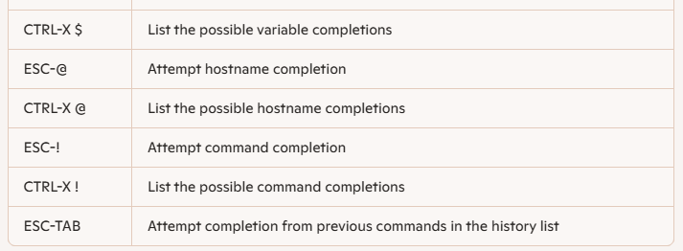

Table 2-6. emacs-mode miscellaneous commands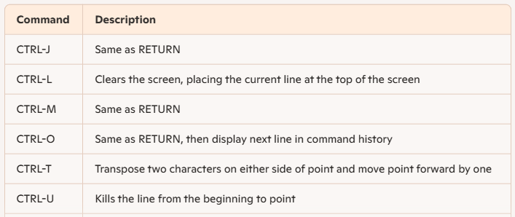

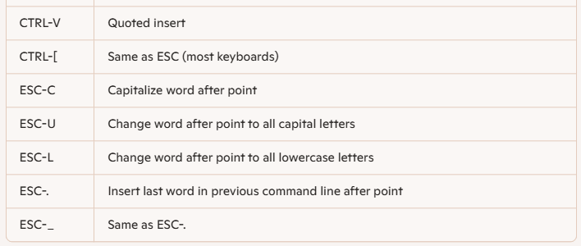

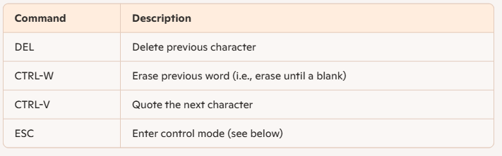

Table 2-8. Basic vi control mode commands 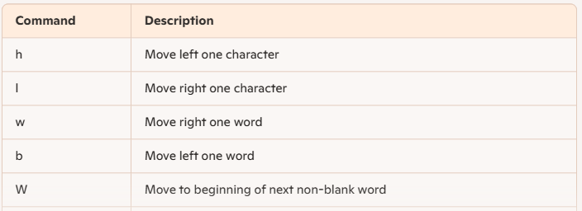

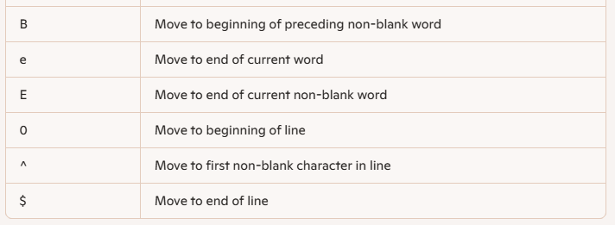

Table 2-9. Commands for entering vi input mode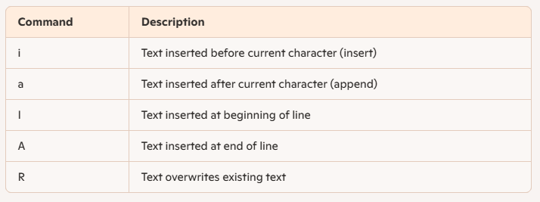

Table 2-10. Some vi-mode deletion commands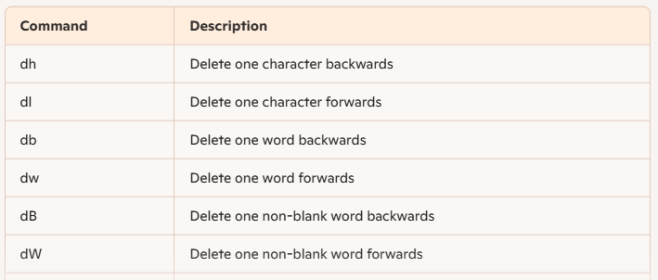

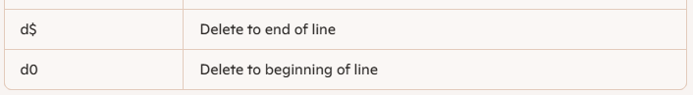

Table 2-11. Abbreviations for vi-mode delete commands

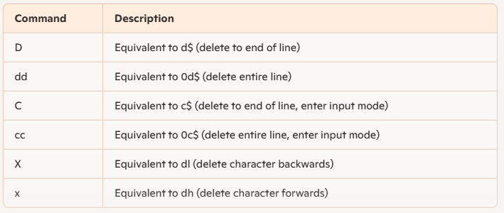

Table 2-12. vi control mode commands for searching the command history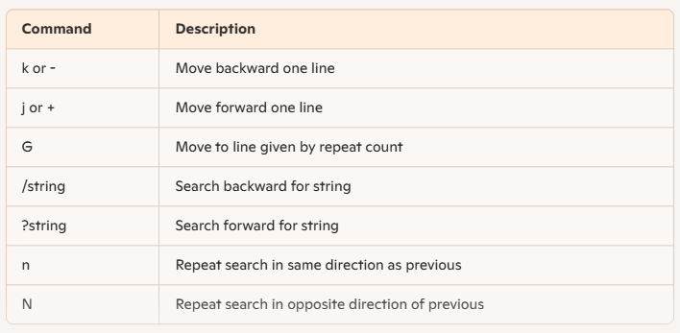

Table 2-13. vi-mode character-finding commands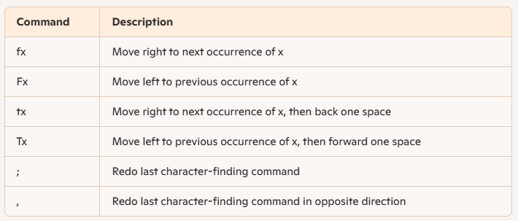

Table 2-14. Miscellaneous vi-mode commands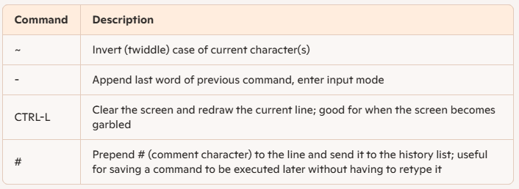

Table 2-15. Event designators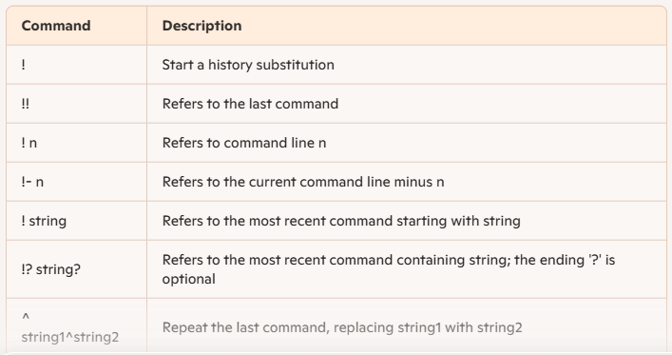

Table 2-16. Word designators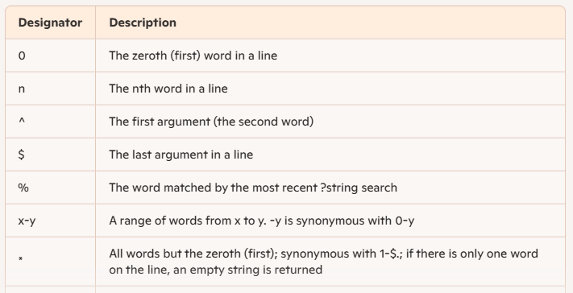

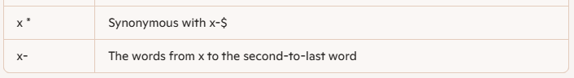

Table 2-17. Modifiers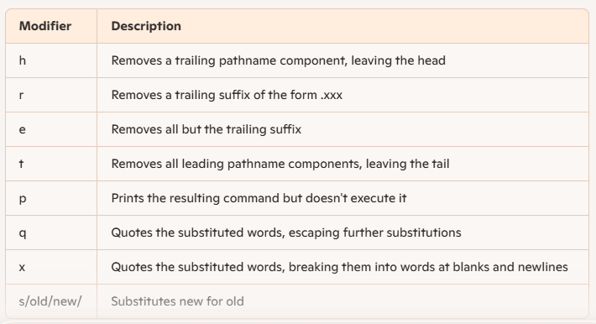

Table 2-18. Escape sequences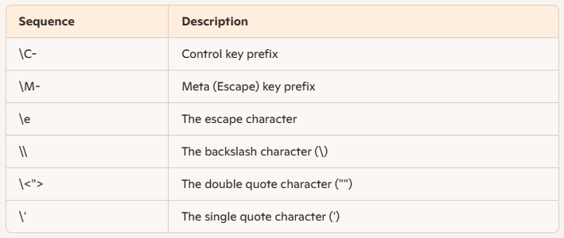

**Table 2-19. readline variables**